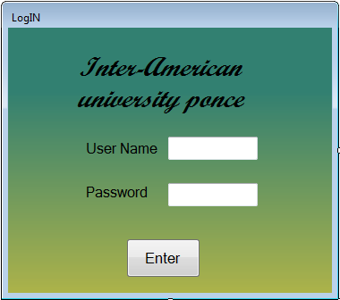

Public Class LogIN

Private Sub LogIN_Load(sender As System.Object, e As System.EventArgs) Handles_

MyBase.Load

txbxUserName.Focus()

End Sub

Private Sub btnEnter_Click(sender As System.Object, e As System.EventArgs) Handles_

btnEnter.Click

If txbxUserName.Text = "User" And txbxPassword.Text = "password" Then

Me.Hide()

Main_Menu.Show()

Else

MsgBox("Wrong password")

txbxPassword.ResetText()

txbxPassword.Focus()

End If

End Sub

End Class

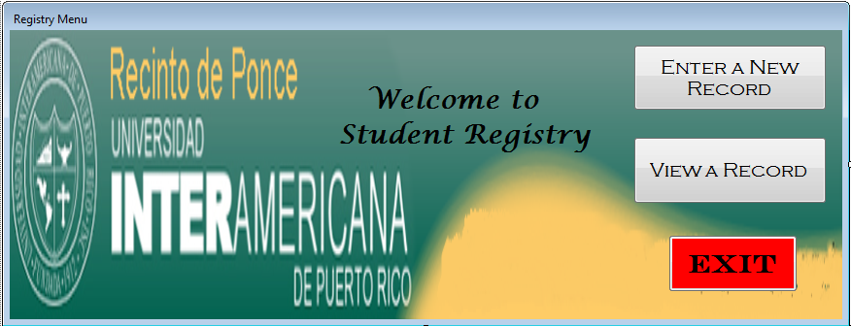

Public Structure datafile2

Public recordID As Integer

<VBFixedString(15)> Public firstname As String

<VBFixedString(10)> Public middlename As String

<VBFixedString(21)> Public lastname As String

Public male As Boolean

Public female As Boolean

<VBFixedString(34)> Public adress As String

<VBFixedString(12)> Public phone As String

End Structure

Public Class Main_Menu

Private Sub Form1_Load(sender As System.Object, e As System.EventArgs) Handles_

MyBase.Load

End Sub

Private Sub btnnewrecord_Click(sender As System.Object, e As System.EventArgs) Handles_

btnnewrecord.Click

Me.Hide()

Form2.Show()

End Sub

Private Sub btnviewrecord_Click(sender As System.Object, e As System.EventArgs) Handles_

btnviewrecord.Click

Me.Hide()

Form3.Show()

End Sub

Private Sub btnexit_Click(sender As System.Object, e As System.EventArgs) Handles_

btnexit.Click

End

End Sub

End Class

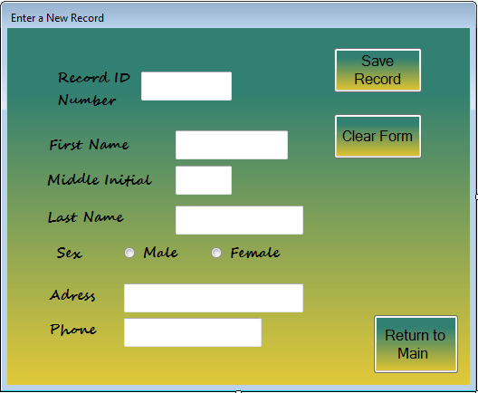

Public Class Form2

Private Sub Form2_Load(sender As System.Object, e As System.EventArgs) Handles MyBase.Load

txtboxrecordID.Focus()

End Sub

Private Sub btnreturntomain_Click(sender As System.Object, e As System.EventArgs) Handles btnretuntomain.Click

Me.Hide()

Main_Menu.Show()

End Sub

Private Sub Label2_Click(sender As System.Object, e As System.EventArgs) Handles Label2.Click

End Sub

Private Sub btnnewrecord_Click(sender As System.Object, e As System.EventArgs) Handles btnnewrecord.Click

Dim recordID As Integer, reclenght As Long, lastrecord As Integer, field As datafile2

field.recordID = 0

field.firstname = " "

field.middlename = " "

field.lastname = " "

field.male = False

field.female = False

field.adress = " "

field.phone = 0

reclenght = Len(field)

recordID = FreeFile()

FileOpen(recordID, "datafile2.dat", OpenMode.Random, OpenAccess.ReadWrite, , reclenght)

field.firstname = txtboxfirstname.Text

field.middlename = txtboxmiddleinitial.Text

field.lastname = txtboxlastname.Text

field.male = radbtnmale.Checked

field.female = radbtnfemale.Checked

field.adress = txtboxadress.Text

field.phone = txtboxphone.Text

lastrecord = txtboxrecordID.Text

FilePut(recordID, field, lastrecord)

FileClose(1)

txtboxrecordID.Text = " "

txtboxfirstname.Text = " "

txtboxmiddleinitial.Text = " "

txtboxlastname.Text = " "

radbtnmale.Checked = False

radbtnfemale.Checked = False

txtboxadress.Text = " "

txtboxphone.Text = " "

txtboxrecordID.Focus()

End Sub

Private Sub btnclearform_Click_1(sender As System.Object, e As System.EventArgs) Handles btnclearform.Click

txtboxrecordID.Text = " "

txtboxfirstname.Text = " "

txtboxmiddleinitial.Text = " "

txtboxlastname.Text = " "

radbtnmale.Checked = False

radbtnfemale.Checked = False

txtboxadress.Text = " "

txtboxphone.Text = " "

txtboxrecordID.Focus()

End Sub

End Class

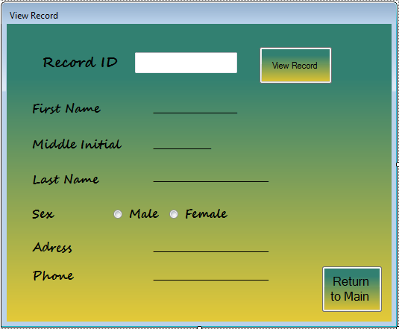

Public Class Form3

Private Sub Form3_Load(sender As System.Object, e As System.EventArgs) Handles_

MyBase.Load

End Sub

Private Sub btnviewrecord_Click(sender As System.Object, e As System.EventArgs) Handles btnviewrecord.Click

Dim recordID As Integer, reclenght As Long, lastrecord As Integer, field As datafile2

field.recordID = 0

field.firstname = " "

field.middlename = " "

field.lastname = " "

field.male = False

field.female = False

field.adress = " "

field.phone = 0

reclenght = Len(field)

recordID = FreeFile()

FileOpen(recordID, "datafile2.dat", OpenMode.Random, OpenAccess.ReadWrite, , reclenght)

lastrecord = Val(txtboxrecordID.Text)

FileGet(recordID, field, lastrecord)

lblfistname.Text = field.firstname

lblmiddleinitial.Text = field.middlename

lbllastname.Text = field.lastname

radbtnmale.Checked = field.male

radbtnfemale.Checked = field.female

lbladress.Text = field.adress

lblphone.Text = field.phone

FileClose(1)

txtboxrecordID.Focus()

End Sub

Private Sub btnretuntomain_Click(sender As System.Object, e As System.EventArgs) Handles btnretuntomain.Click

Me.Hide()

Main_Menu.Show()

End Sub

End Class